**ABHIJIT DASH**

**RA1811031010112**

**IMPLEMENTATION OF DAG**

**AIM:-**

To create DAG in CFG

**CODE:-**

#include <stdio.h>

#include <stdlib.h>

#include <time.h>

#define MIN_PER_RANK 1

#define MAX_PER_RANK 5

#define MIN_RANKS 3

#define MAX_RANKS 5

#define PERCENT 30

int main()

{

int i, j, k, nodes = 0;

srand(time(NULL));

int ranks = MIN_RANKS + (rand() % (MAX_RANKS - MIN_RANKS + 1));

printf("DIRECTED ACYCLIC GRAPH\n");

for (i = 1; i < ranks; i++)

{

int new_nodes = MIN_PER_RANK + (rand() % (MAX_PER_RANK - MIN_PER_RANK + 1));

for (j = 0; j < nodes; j++)

for (k = 0; k < new_nodes; k++)

if ((rand() % 100) < PERCENT)

printf("%d->%d;\n", j, k + nodes);

nodes += new_nodes;

}

return 0;

}

**OUTPUT SCREENSHOTS:-**

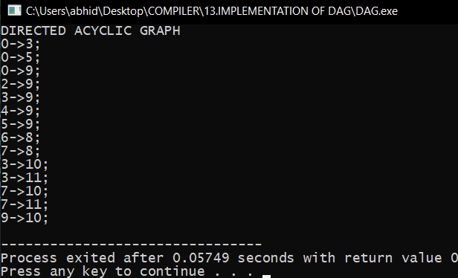

**RESULT:-**

The implementation is done successfully.